**INDEX**

|  |  |  |  |
| --- | --- | --- | --- |
| **S#** | **Date** | **Object** | **Sig** |
| 1 | 3.3.22 | LAB 1 |  |
| 2 | 3.3.22 | Activity 1: How to start MS Project (Standard Version) |  |
| 3 | 3.3.22 | Activity 2: How to create Project Plan from a Template |  |
| 4 | 3.3.22 | Activity 3: How to switch to a different view |  |
| 5 | 3.3.22 | Activity 4: How to view a report in the Print Preview Window |  |
| 6 | 3.3.22 | Activity 5: How to view a report in the Print Preview Window |  |
| 7 | 4.3.22 | LAB 2 |  |
| 8 | 4.3.22 | Activity 1: How to create a new project plan and set its starting date. |  |
| 9 | 4.3.22 | Activity 2: How to set working and non-working time |  |
| 10 | 4.3.22 | Activity 3: How to set properties about a Project Plan |  |
| 11 | 4.3.22 | Activity 4: How to enter tasks, task duration and milestone in Project. |  |
| 12 | 4.3.22 | Activity 5: How to organize tasks into phases |  |
| 13 | 10.3.22 | LAB 3 |  |
| 14 | 10.3.22 | Activity 1: Creating a Milestone |  |
| 15 | 10.3.22 | Activity 2: Creating recurring Task |  |
| 16 | 10.3.22 | Activity 3: Creating Work Breakdown Structure |  |
| 17 | 10.3.22 | Activity 4: Assign Predecessor to Task: |  |
| 18 | 10.3.22 | Activity 5: Network Diagram: |  |
| 19 | 17.3.22 | LAB 4 |  |
| 20 | 17.3.22 | 2.1 Displaying the Resource Sheet |  |
| 21 | 17.3.22 | 2.2 Adding Resource Attributes |  |
| 22 | 17.3.22 | 2.3 Entering Multiple Payrates |  |
| 23 | 17.3.22 | 2.4 Entering Equipment and Material Resources |  |
| 24 | 17.3.22 | 2.5 Editing Resource Calendar |  |
| 25 | 17.3.22 | 2.6 Dealing with over allocated Resources |  |
| 26 | 17.3.22 | 2.7 Levelling Resources |  |
| 27 | 17.3.22 | 2.8 Exercises |  |
| 28 | 17.3.22 | 2.8.1.1 Enter the list of Resources |  |
| 29 | 17.3.22 | 2.8.1.2 Entering cost for each Resource |  |
| 30 | 17.3.22 | 2.8.1.3 Assigning each resource to the task |  |
| 31 | 17.3.22 | 2.8.1.4 Resource Usage |  |
| 32 | 17.3.22 | 2.8.1.5 Dealing with over allocated Resources |  |
| 33 | 17.3.22 | 2.8.1.6 Levelling Resources |  |
| 34 | 17.3.22 | 2.8.2 Gantt Diagram with Resources Assigned |  |
| 35 | 17.3.22 | 2.8.3 Network Diagram with Resource Assigned |  |
| 36 | 17.3.22 | 2.8.4 Assigning Resource Availability |  |

**LAB 1**

**Activity 1: How to start MS Project (Standard Version)**

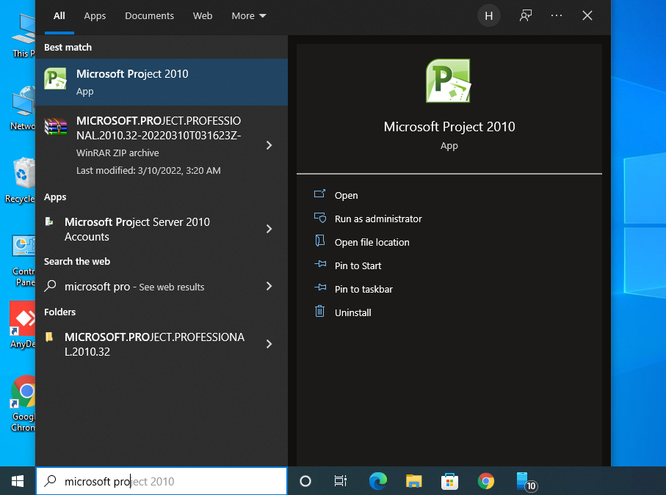**Ans:** Click on search bar and wirte Microsoft Project and then enter

**Activity 2: How to create Project Plan from a Template**

**Ans:** Click on New in File Menu and select template.

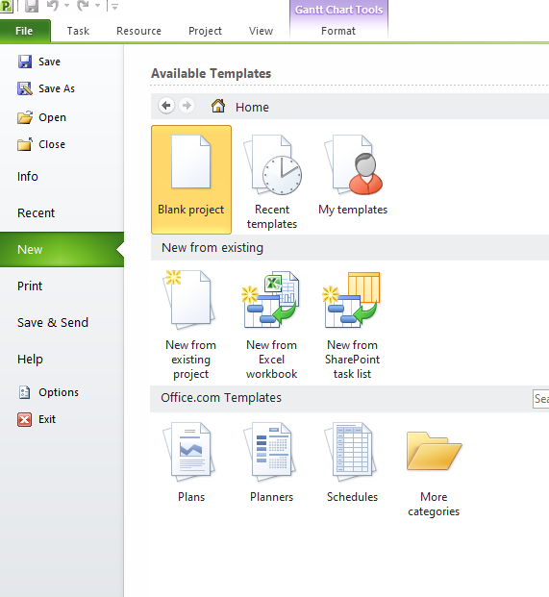

**Activity 3: How to switch to a different view**

**Ans:** Click on View tab and select your view, if not available, click on

More view in other views dialogue

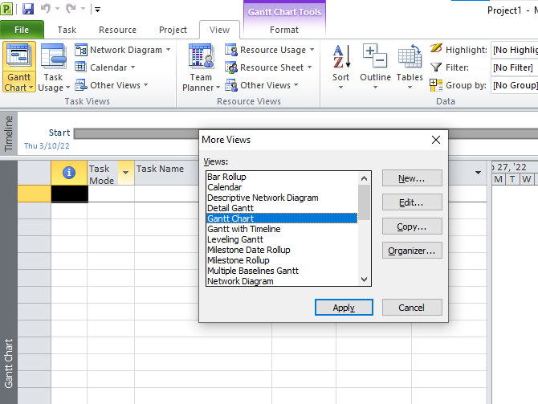

**Activity 4: How to view a report in the Print Preview Window**

**Ans:** Click on Reports in Project tab , for custom click Custom and select

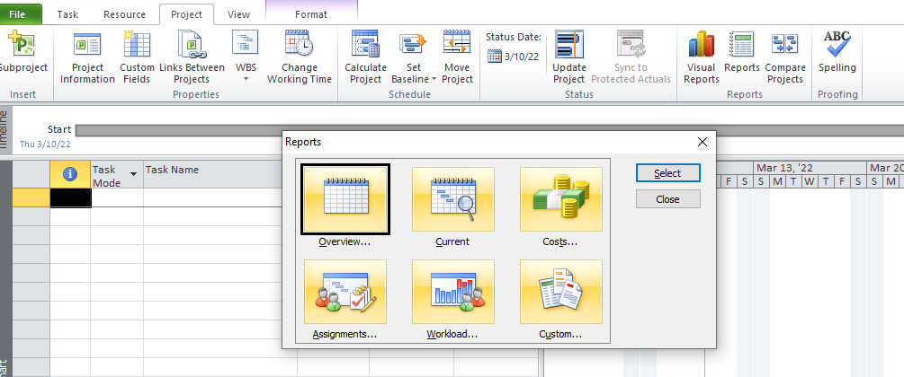

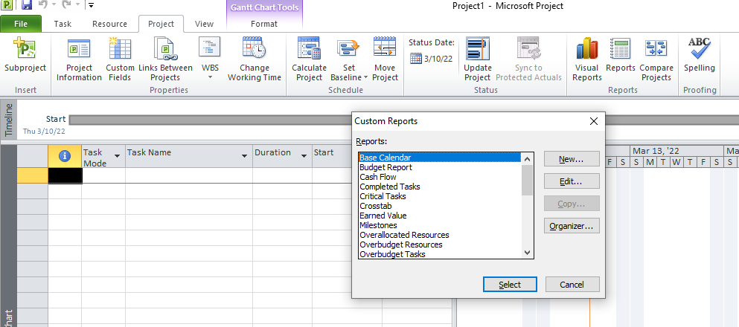

**Activity 5: How to view a report in the Print Preview Window**

**Ans:** Click on Visual Reports in Project tab and select the visual report you want.

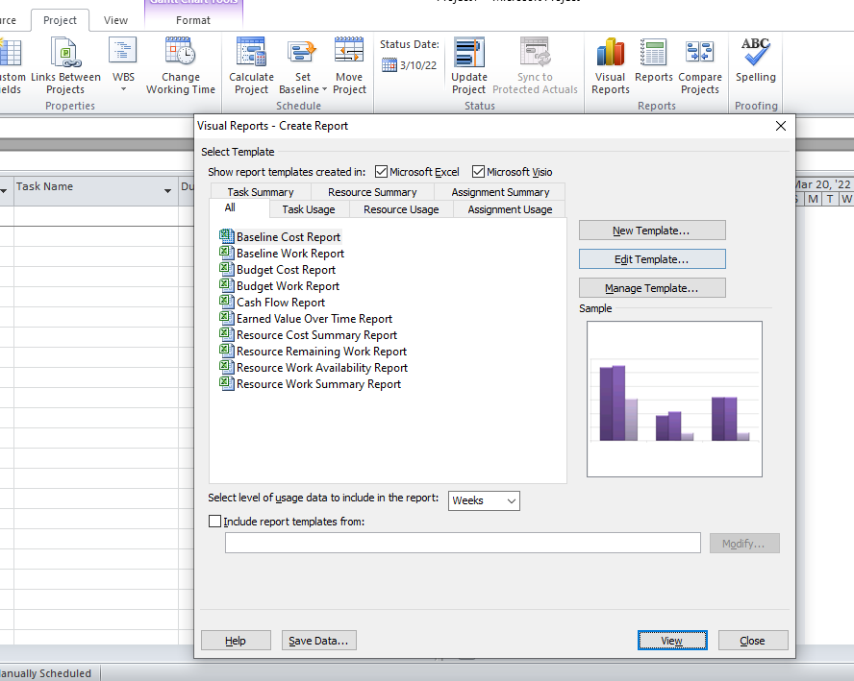

**LAB 2**

**Activity 1: How to create a new project plan and set its starting date.**

**Ans:** To create new project, open Microsoft Project. In File Menu click New and then Blank project and then create button. To set starting date click Project Information in Project tab and then in start date box select date.

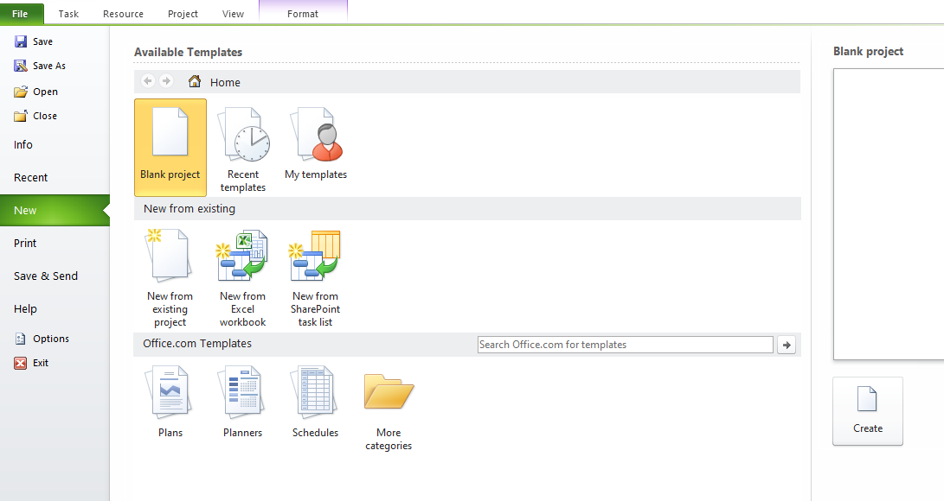

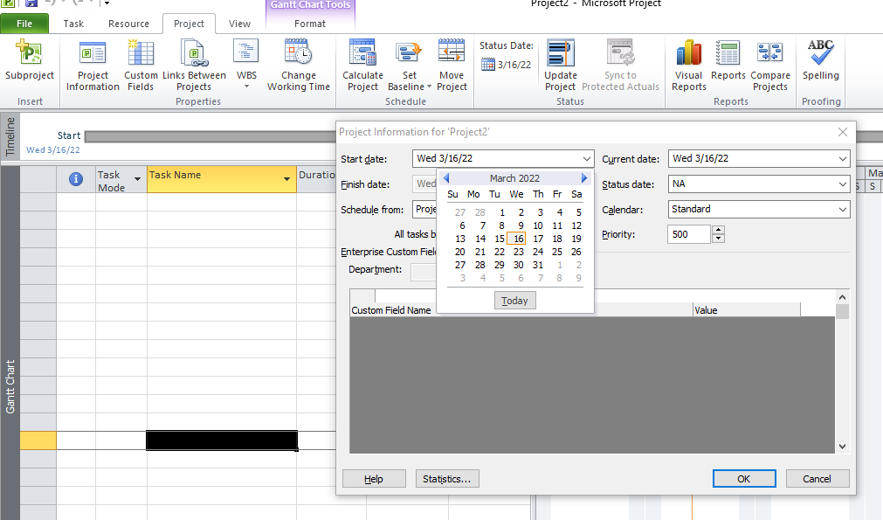

**Activity 2: How to set working and non-working time.**

**Ans:** Click on ‘Change Working Time’ in Project tab. In For calendar box, select your custom calendar. Enter exception like Holidays etc. in Name filed then click on details to set working time and recurrence patter for the exception. To change default non-working days and time click on details button Work Weeks tab in Change Working Time dialogue box

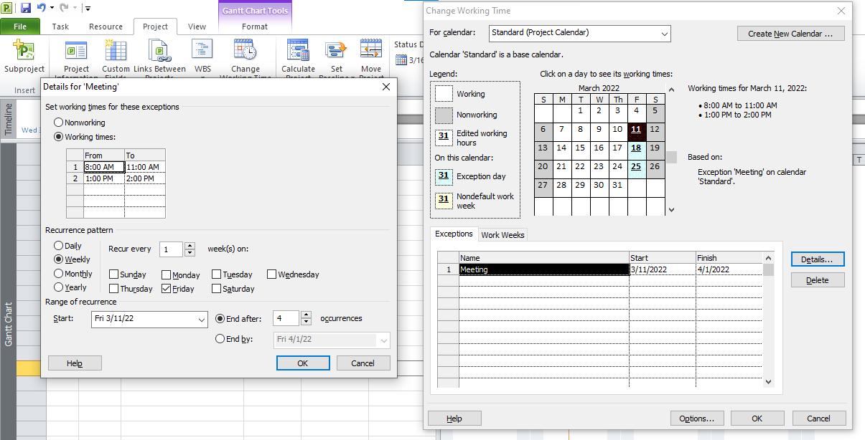

**Activity 3: How to set properties about a Project Plan**

**Ans:** Click on info in File Menu, click Project Information, select Advanced Properties. In the properties dialogue box, click summary tab and then enter the information you want.

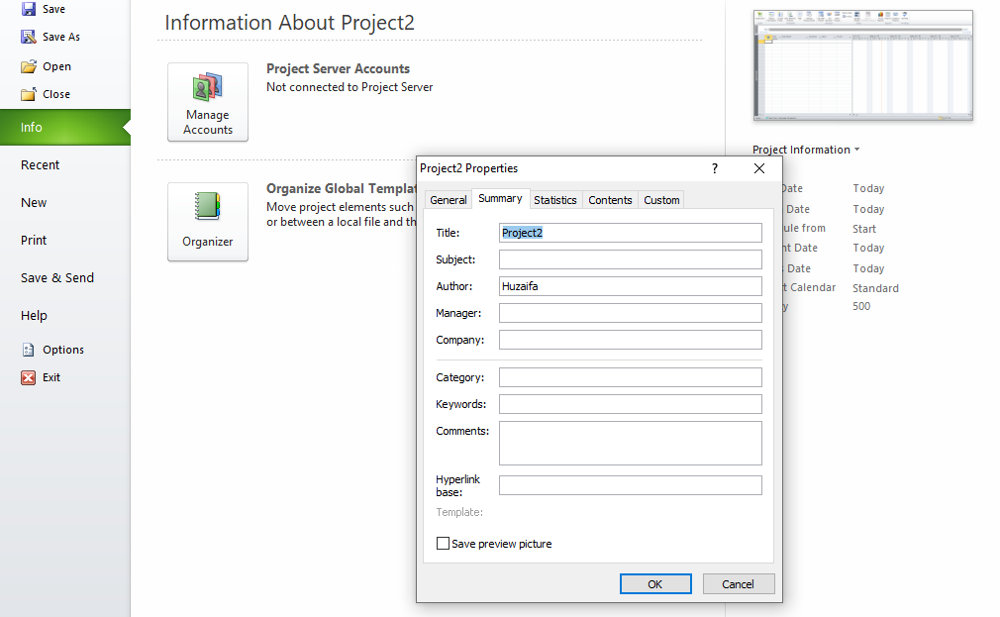

**Activity 4: How to enter tasks, task duration and milestone in Project.**

**Ans:** Click on Grant Chart view in View tab and enter tasks and their duration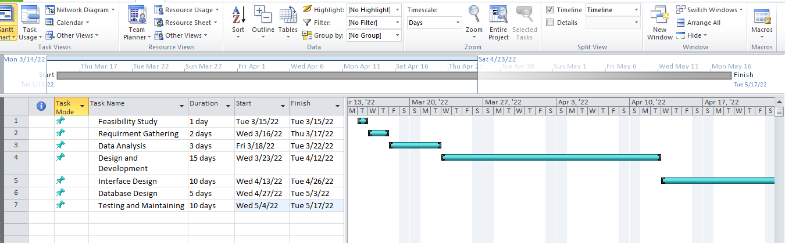

**Activity 5: How to organize tasks into phases**

**Ans:** Click on task and then task tab. Click indent task in Schedule category.

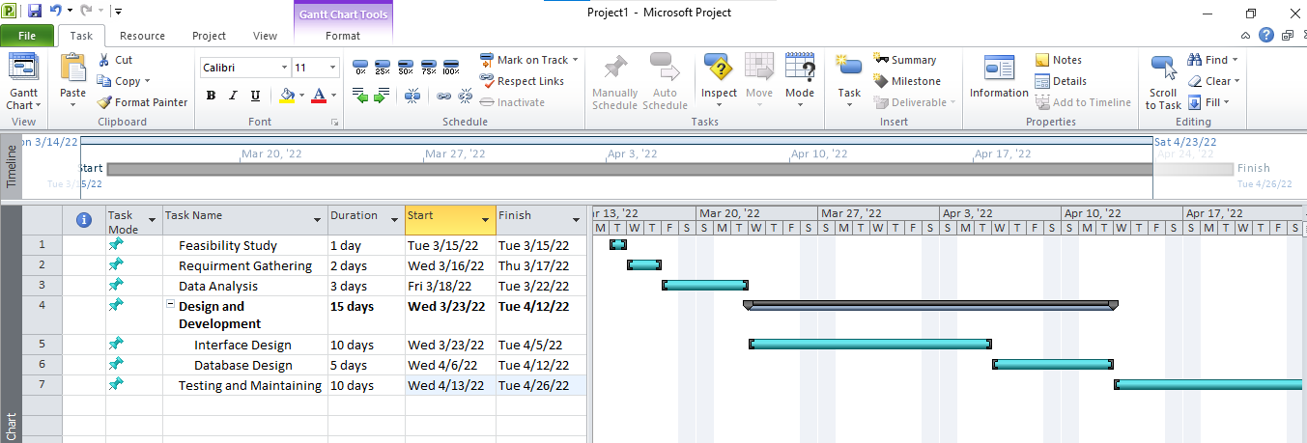

**LAB 3**

**Activity 1: Creating a Milestone**

**Ans:** To create milestone, set the duration of task to 0 days

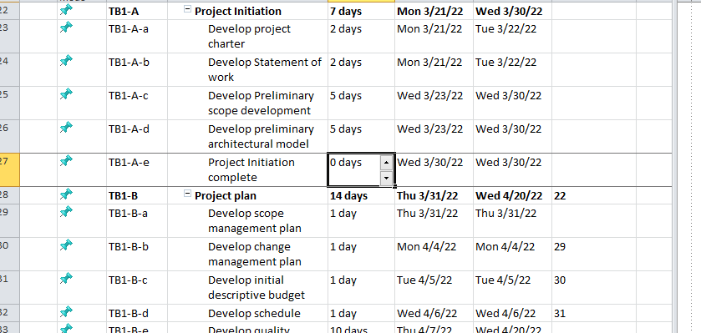

**Activity 2: Creating recurring Task**

**Ans:** To make task recurring, select task, click task in Insert category in the task tab, a popup is open and chose your recurrent days

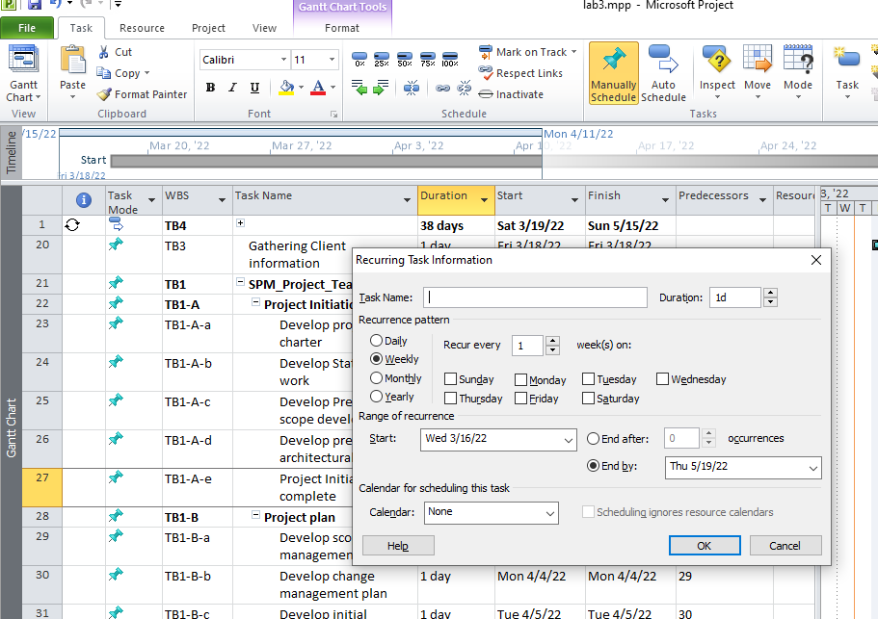

**Activity 3: Creating Work Breakdown Structure**

**Ans:** To create WBS, insert WBS column. For custom WBS, click Define Code in WBS dropdown in Properties category in Project Tab. Set your Code and click OK.

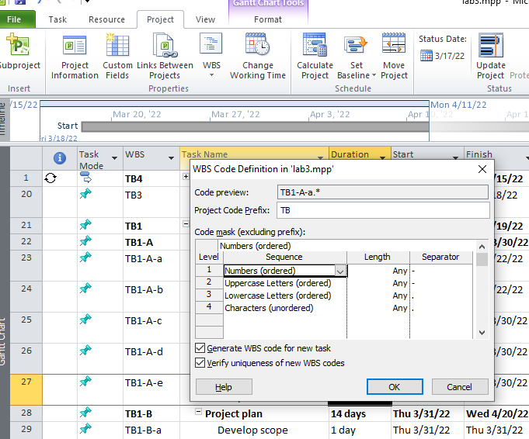

**Activity 4: Assign Predecessor to Task:**

**Ans:** To assign predecessor to task double click on task a popup is open click predecessors tab and enter the predecessor task ID or Name in ID or Task Name Fields then select Type and click ok

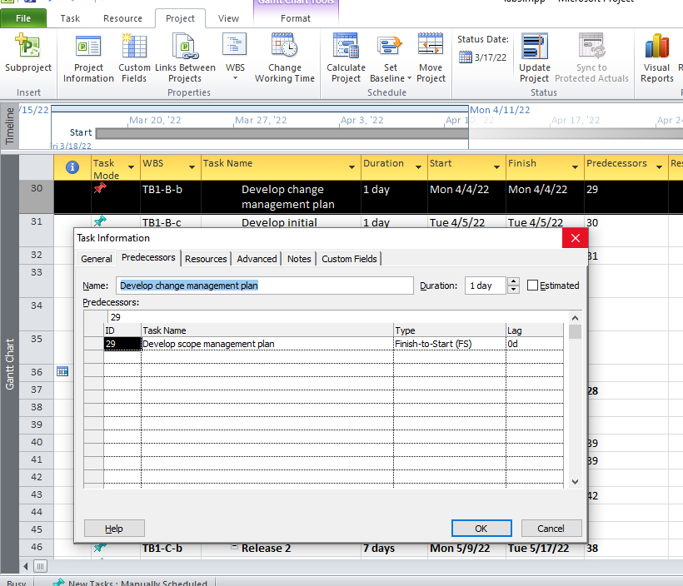

**Activity 5: Network Diagram:**

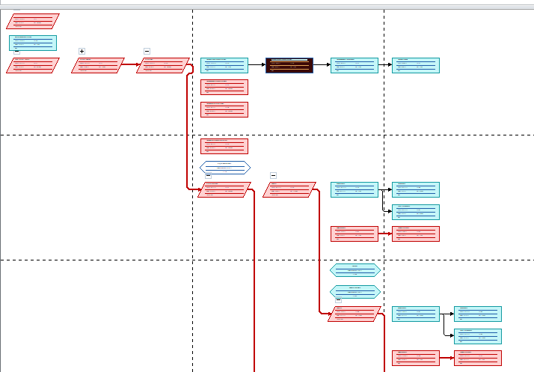**Ans:** To view network diagram of project click Network Diagram, in View Tab

**LAB 4**

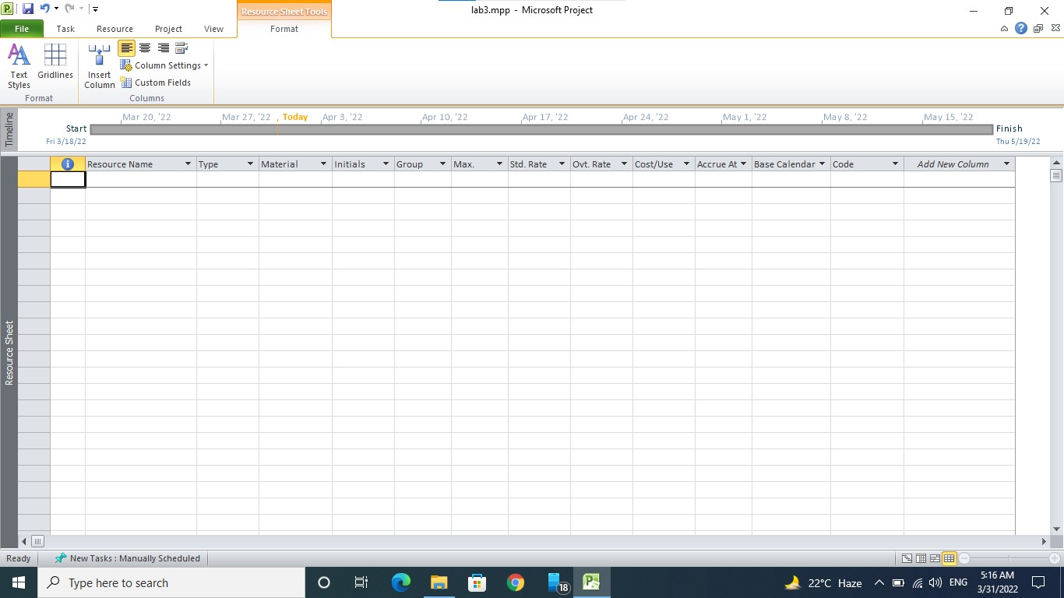**2.1 Displaying the Resource Sheet:**

**2.2 Adding Resource Attributes:**

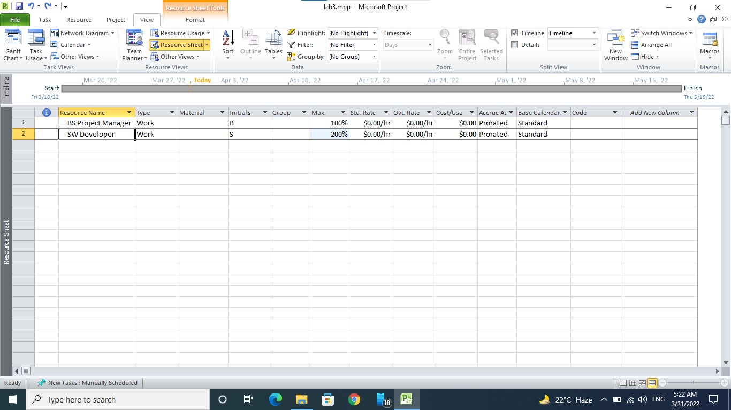

**2.3 Entering Multiple Pay Rates:**

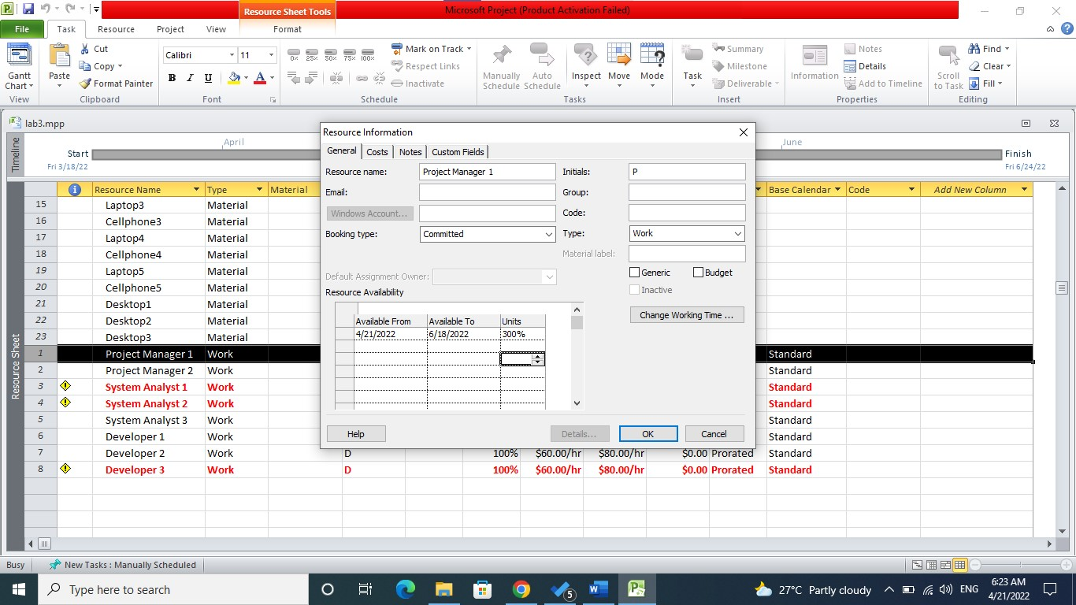

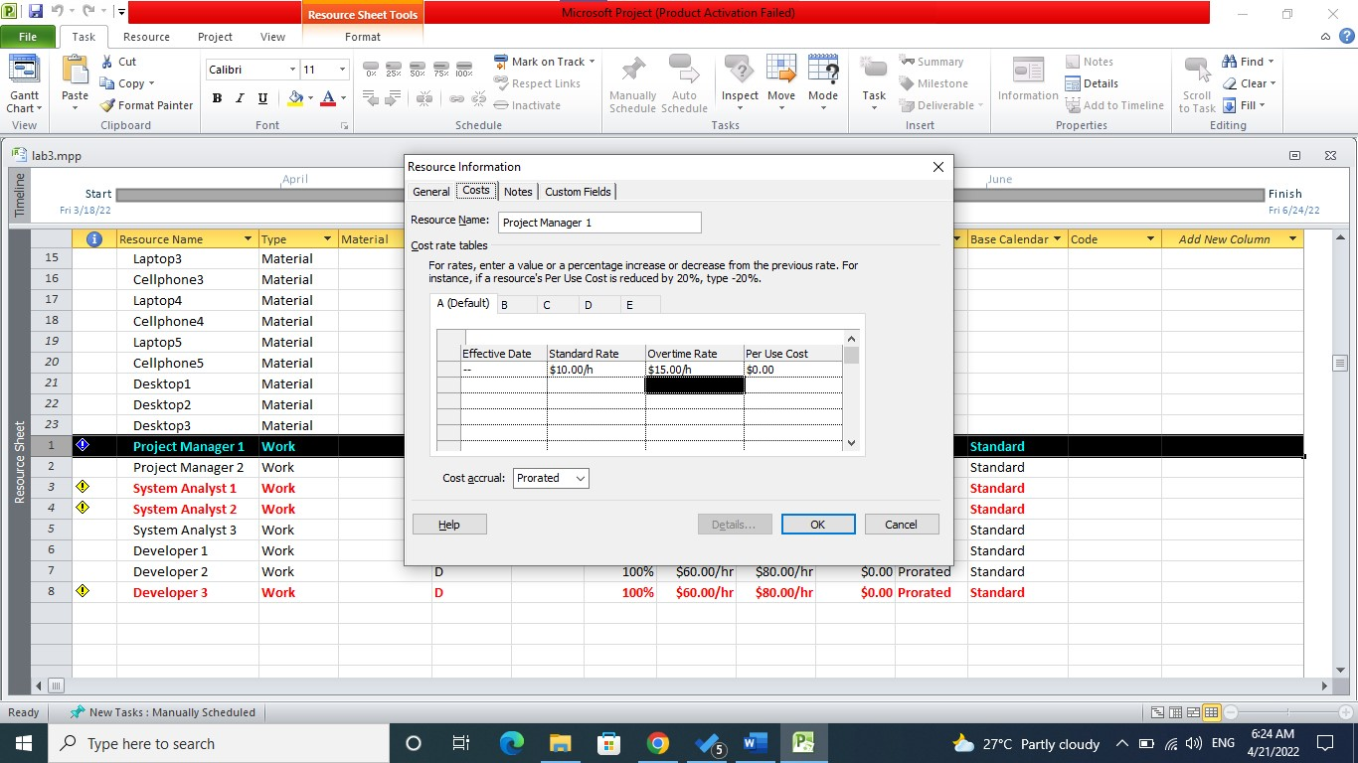

**2.4 Entering Equipment and Material Resources:**

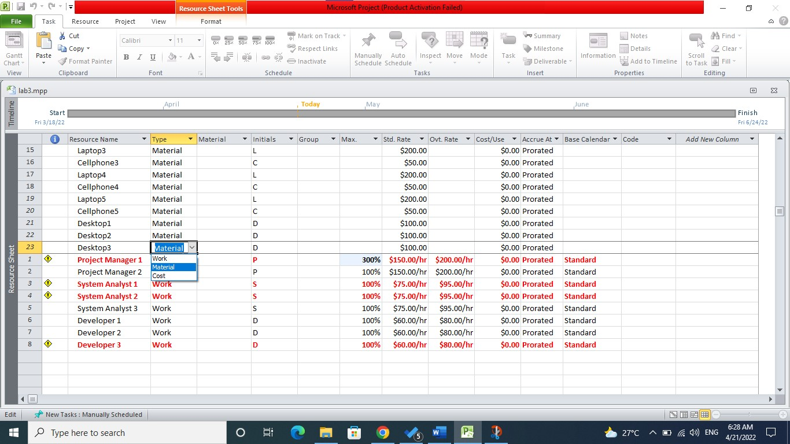

**2.5 Editing the Resource Calendar:**

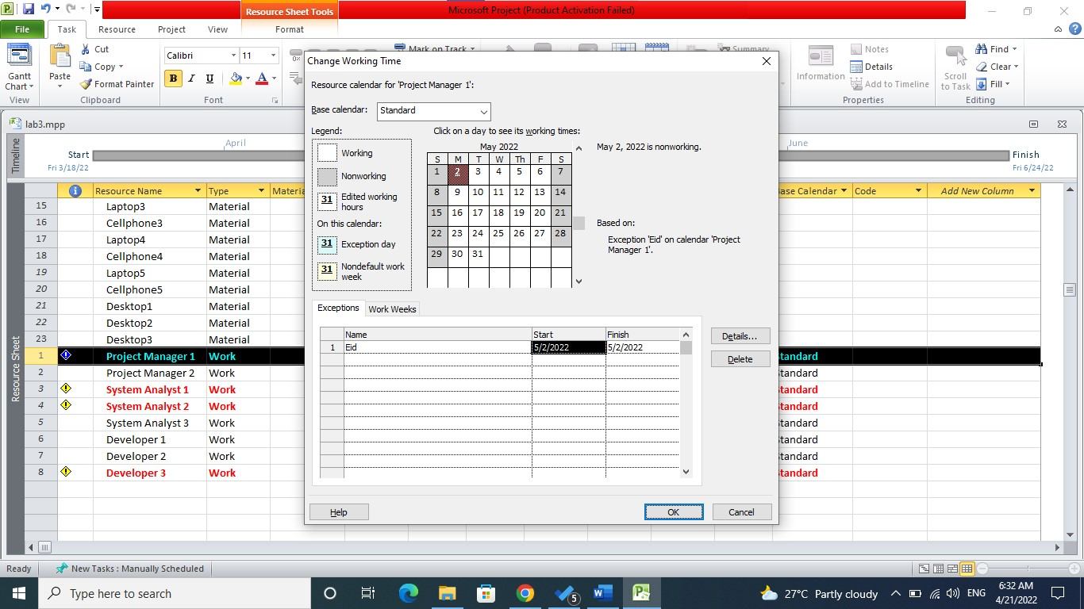

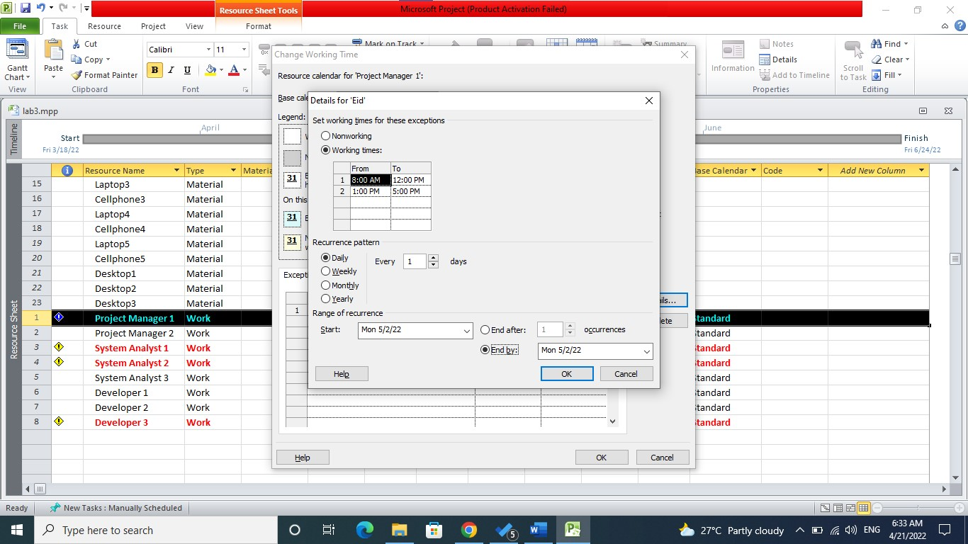

**2.6 Dealing with over Allocated Resources**

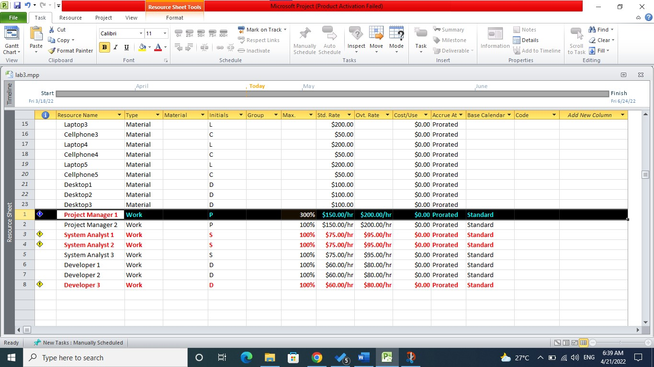

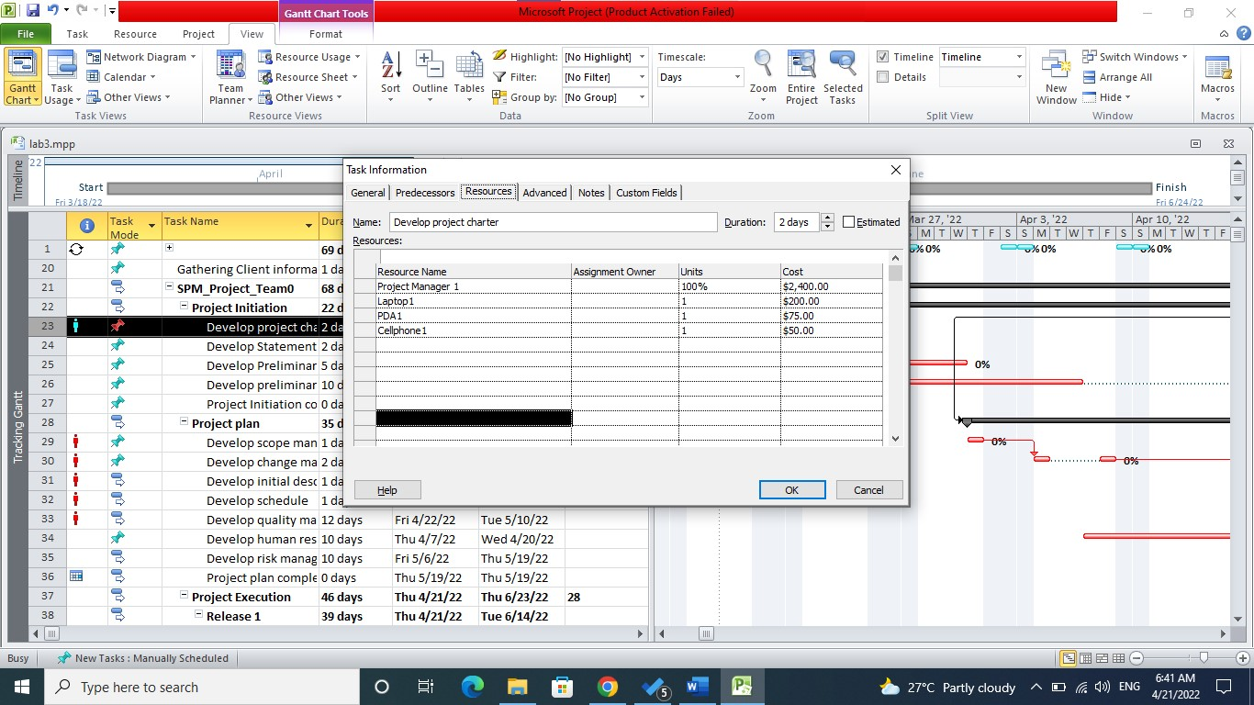

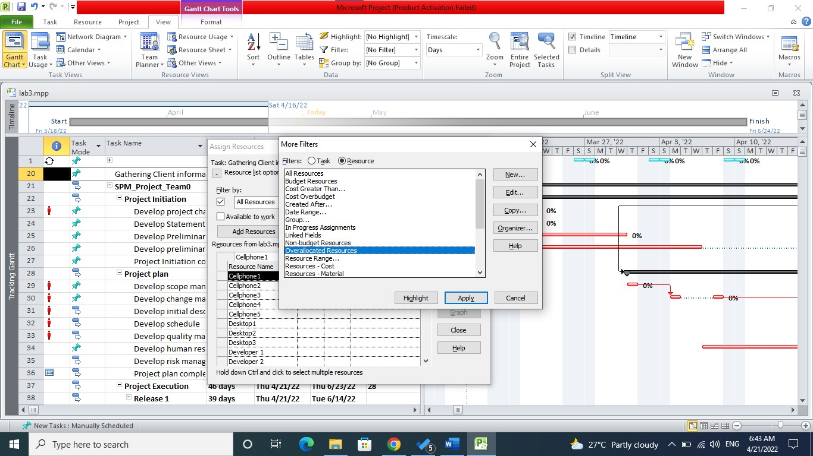

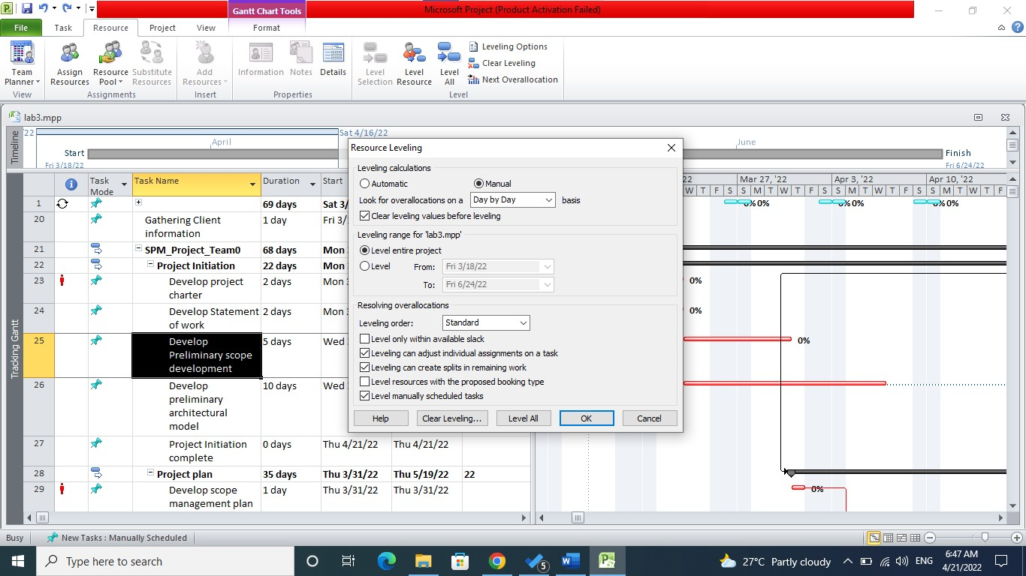**2.7 Levelling Resources:**

**2.8 Exercies**

**2.8.1.1 Enter the list of Resources:**

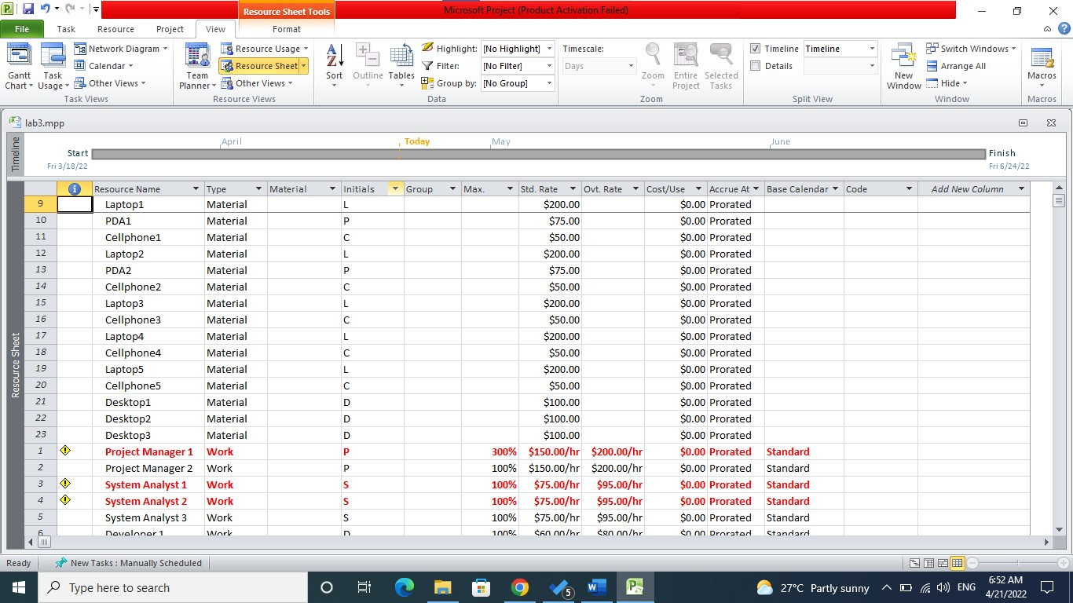

**2.8.1.2 Entering cost for Each Resource**

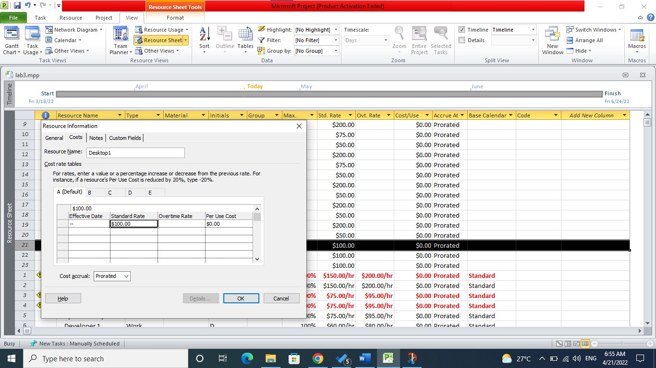

**2.8.1.3 Assigning Resource to each Task**

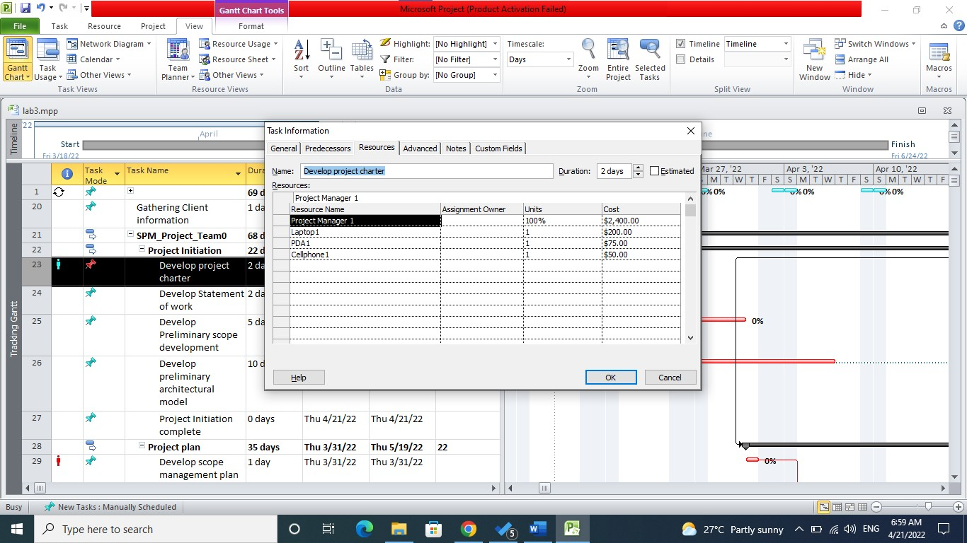

**2.8.1.4 Resource Usage**

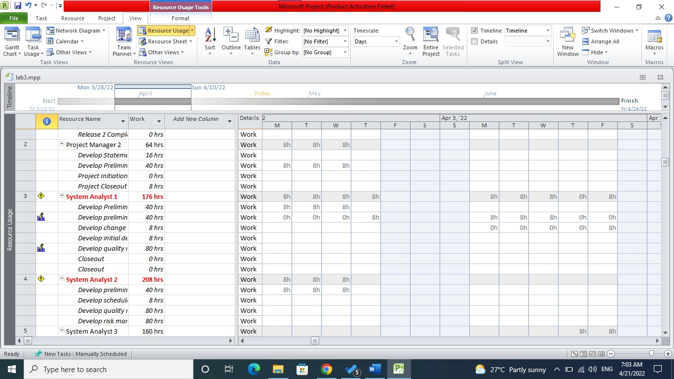

**2.8.1.5 Dealing with over allocated Resources**



**2.8.1.6 Levelling Resources**

**2.8.2 Gantt Diagram with Resources Assigned**

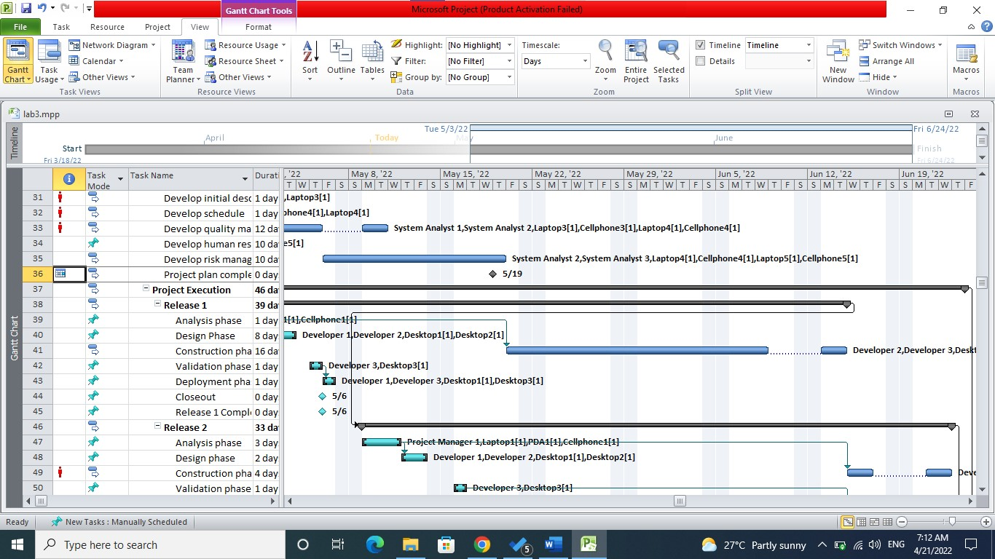

**2.8.3 Network Diagram with Resource Assigned**

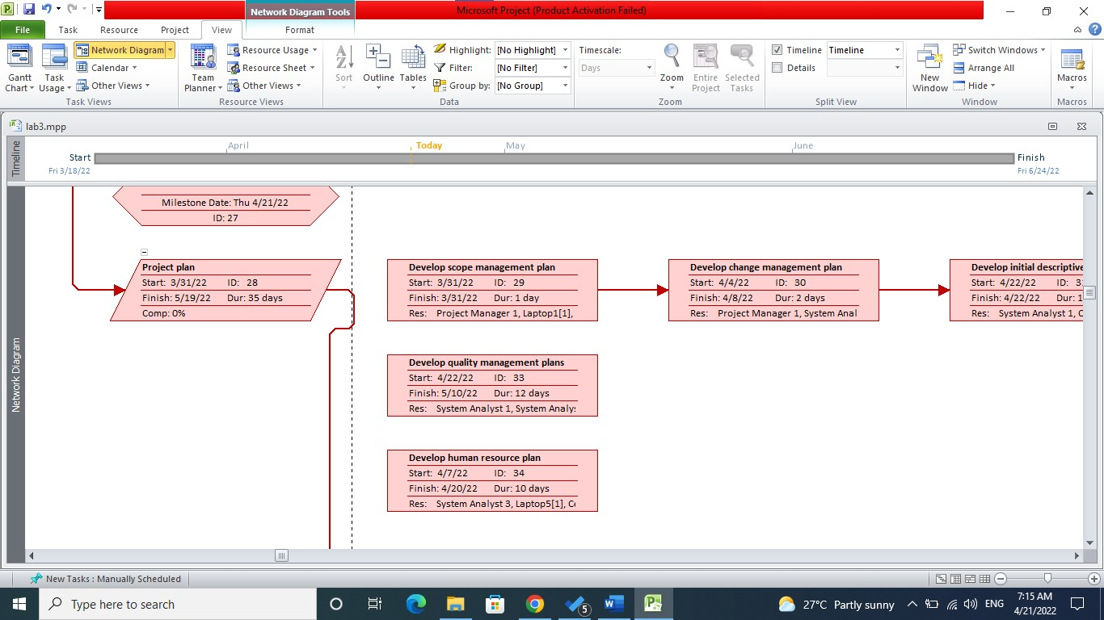

**2.8.4 Assigning Resource Availability**

